2024-10-14 2041 Morgan Jassen on lemonmama.com

Oh, dang.
My coffee cup is on the floor.
This is awkward:

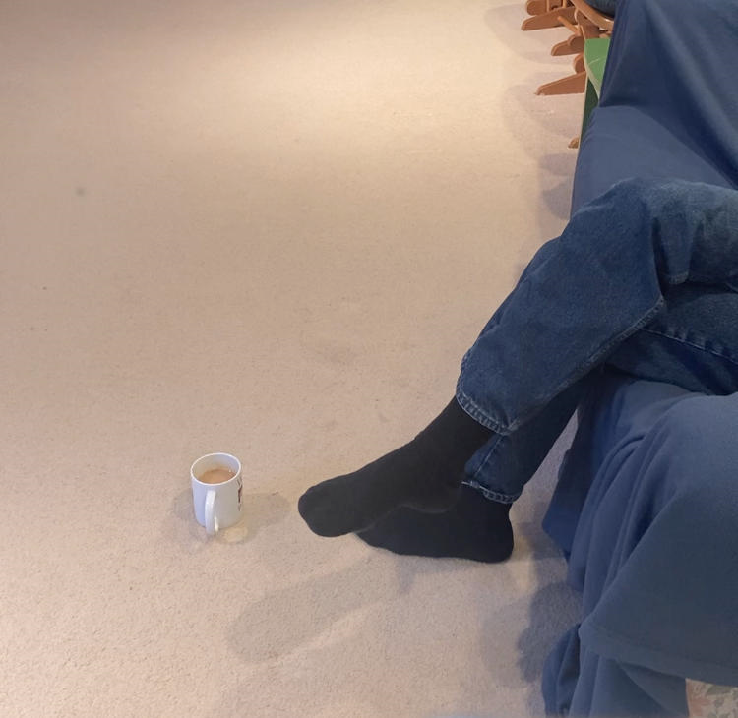

So crude.
Would be much better if it had a coaster underneath it. ...

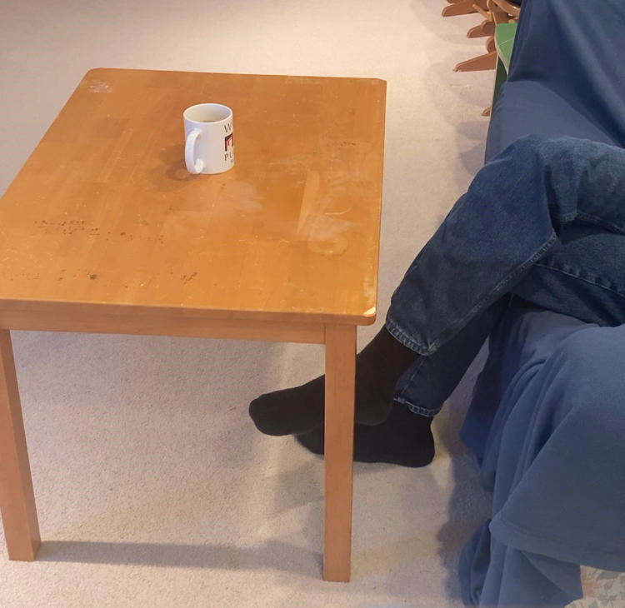

Ahhh..... Much better!

#0032

